| **S. No.** | **Content** | **Page No.** |
| --- | --- | --- |
| 1 | Title Page | i |
| 2 | Acknowledgement | ii |
| 3 | Abstract | iii |
| 4 | Table of Contents | iv |
| 5 | **Chapter 1: Introduction** | 1 |
|  | 1.1 Overview of Cold Storage |  |
|  | 1.2 Objective of the Project |  |
|  | 1.3 Scope of the Project |  |
|  | 1.4 Methodology Used |  |
|  | 1.5 Tools and Technologies Used |  |
| 6 | **Chapter 2: System Analysis** | 7 |
|  | 2.1 Problem Statement |  |
|  | 2.2 Existing System |  |
|  | 2.3 Proposed System |  |
|  | 2.4 Feasibility Study |  |
|  | - Technical Feasibility |  |
|  | - Economic Feasibility |  |
|  | - Operational Feasibility |  |
|  | 2.5 Cost-Benefit Analysis |  |
| 7 | **Chapter 3: System Design** | 15 |
|  | 3.1 Context Level DFD |  |
|  | 3.2 Level 1 DFD |  |
|  | 3.3 Level 2 DFD (if applicable) |  |
|  | 3.4 Entity Relationship Diagram (ERD) |  |
|  | 3.5 Cloud Level Diagram (CLD) |  |
|  | 3.6 Database Design |  |
|  | 3.7 System Architecture |  |
|  | 3.8 User Interface Design |  |
| 8 | **Chapter 4: System Implementation** | 25 |
|  | 4.1 Platform Details |  |
|  | 4.2 Module Description |  |
|  | 4.3 Input and Output Design |  |
| 9 | **Chapter 5: Testing** | 32 |
|  | 5.1 Testing Strategy |  |
|  | 5.2 Test Cases |  |
|  | 5.3 Bug Tracking |  |
|  | 5.4 Validation |  |
| 10 | **Chapter 6: Conclusion & Future Scope** | 37 |
|  | 6.1 Achievements |  |
|  | 6.2 Limitations |  |
|  | 6.3 Future Enhancements |  |
| 11 | **Chapter 7: References** | 41 |

### 📑

## 📘 ****Abstract****

The **Cold Storage Management System** is a smart solution designed to efficiently manage and monitor perishable inventory stored in controlled environments. The system automates operations such as stock insertion with automatic ID generation, real-time tracking of temperature and humidity, inventory updates, and dispatch processing. Key functionalities include inventory tracking, environmental condition monitoring, alert configuration, and report generation for compliance. The system features a modern, animated UI with distinct sections for insertion, updating, tracking, dispatching, and generating detailed logs and reports.

This project is ideal for cold chain logistics companies, warehouses, and food storage units where product preservation is critical. The system also allows optional advanced search by Item ID, category, or quantity, ensuring detailed control and transparency.

## ****Introduction****

### 1.1 ****Project Overview****

The **Cold Storage Management System** is a web-based application designed to efficiently manage and monitor temperature-sensitive inventory in a cold storage environment. Built using **Java Servlet technology with JSP for the front end**, and **MySQL (via MySQL Workbench)** for data storage, the system allows users to perform essential operations such as inserting new stock, tracking inventory in real time, updating environmental conditions, dispatching items, and generating detailed reports.

The application also includes a user authentication system that allows for **account creation (sign-up)** and **login verification**. User credentials are securely stored in the database, and the system validates login data to ensure only registered users gain access.

With an animated and user-friendly interface built on JSP and styled with modern CSS, the platform provides dynamic sections for managing different operations: Insert, Update, Track, Dispatch, and Reports.

### 1.2 ****Objectives****

* To automate cold storage inventory management through a centralized web system.
* To provide **automatic ID generation** for new stock entries.
* To monitor and adjust **temperature and humidity** in real time.
* To manage inventory location, shelf life, and live storage data.
* To allow **dispatch and shipping record management**.
* To **verify user identity** during login and store user accounts during sign-up.
* To generate reports for **compliance and inventory tracking**.

### 1.3 ****Scope of the Project****

This project is intended for organizations involved in the cold chain supply and storage of perishable goods. It helps staff manage inventory, adjust environmental controls, and ensure compliance with industry standards. Key features include:

* Stock Insertion with temperature, expiry, and quantity data.
* Auto-generated unique item IDs.
* Stock Updates: Temperature, humidity, and alerts.
* Real-time tracking of items.
* Dispatch features: Transfers and shipment generation.
* Report generation: Temperature logs, usage records, compliance reports.
* **User login and sign-up** system with database verification.
* UI designed in JSP with animations and responsive layouts.

### 1.4 ****Technologies Used****

| **Component** | **Technology** |
| --- | --- |
| Front-End | JSP |
| Back-End | Java Servlets |
| Database | MySQL (Managed via Workbench) |
| IDE / Editor | Eclipse IDE |
| Application Server | Apache Tomcat |
| Authentication | Servlet-based login/signup with DB validation |

### 1.5 ****Methodology****

The project development follows the **Agile Methodology**, emphasizing iterative design, feedback, and continuous improvement. The application is divided into modular components—Insert, Update, Track, Dispatch, and Reports—each developed and tested individually before full integration. Special focus was given to secure login mechanisms and real-time data handling for temperature-sensitive products.

## ****System Analysis****

### 2.1 ****Problem Statement****

Cold storage facilities often manage large volumes of perishable goods that require precise environmental conditions such as controlled temperature and humidity. In traditional systems, inventory tracking, environmental monitoring, and record-keeping are often done manually or through disconnected systems. This leads to inefficiencies such as:

* Inaccurate stock records
* Delays in dispatch or replenishment
* Manual errors in temperature logs
* Lack of automated alerts for environmental issues
* Difficulty in compliance reporting

There is a need for a centralized, automated, and real-time system that manages inventory and environmental conditions effectively while supporting user access control and data-driven decision-making.

### 2.2 ****Existing System****

* Most current cold storage operations rely on:
* Paper-based records or Excel sheets
* Manual entry of stock data
* Separate systems for temperature monitoring
* No real-time alerts or auto-ID generation
* Poor integration between modules (insert, update, dispatch)
* No online interface for remote access or cloud integration
* No user login system or role-based access

These limitations increase the chances of spoilage, human error, and regulatory non-compliance.

### 2.3 ****Proposed System****

The proposed **Cold Storage Management System** is a web-based application developed using **Java Servlets and JSP**, backed by **MySQL** database. It provides:

* **Automatic stock ID generation**
* **Real-time inventory tracking**
* **Environmental condition monitoring and alert configuration**
* **Login and sign-up functionality for secure user access**
* **Role-based operation (Insert, Update, Track, Dispatch, Reports)**
* **Animated and responsive UI with clear dashboards**
* **Database-driven operations with integrity and validation checks**
* **Filtering tools for searching by ID, category, or quantity**
* **Report generation for temperature logs, usage, and compliance**

This system enhances efficiency, reduces spoilage, and ensures compliance through centralized automation.

### 2.4 ****Feasibility Study****

#### 🔧 Technical Feasibility

**Technology Stack**: The project uses standard and proven technologies like Java Servlets, JSP, MySQL, and Eclipse IDE, all of which are widely supported and scalable.

**Compatibility**: The application can be deployed on Apache Tomcat and integrated with cloud services for further expansion.

**Skills Availability**: Developers familiar with Java EE and MySQL can easily manage and extend the system.

#### 💰 Economic Feasibility

**Development Tools**: All tools used (Eclipse, MySQL, Tomcat) are free and open-source, reducing cost.

**Hosting**: Can be hosted on low-cost servers or on-premise infrastructure.

**Maintenance**: Minimal maintenance cost due to modular design and structured coding.

#### 🛠️ Operational Feasibility

**User-Friendly Interface**: The system has a clean, animated UI which is easy to use for staff and admins.

**Secure Access**: Login functionality ensures only authorized users can make changes

**Efficient Process Flow**: Insert, Update, Track, and Dispatch modules cover all necessary operations in a logical and user-centric way.

### 2.5 ****Cost-Benefit Analysis****

| **Cost Element** | **Estimated Cost** |
| --- | --- |
| Development (Java, JSP, MySQL) | Low (Open-source tools) |
| Deployment (Tomcat, Web Server) | Moderate (once-time setup) |
| Training Staff | Low (Simple UI) |
| Maintenance | Low |

| **Benefits** | **Impact** |
| --- | --- |
| Automated ID and Inventory Control | Reduced human error |
| Real-Time Monitoring | Improved decision-making |
| Alerts & Report Generation | Ensures compliance |
| Fast Dispatch & Tracking | Operational efficiency |
| Login & Security | Controlled data access |

* **System Design**

### 3.1 ****Context Level Data Flow Diagram (DFD)****

The **Context Level DFD** provides a high-level overview of the Cold Storage Management System and its interaction with external entities. This diagram represents the system as a single process that interacts with external entities like Users, Sensors, and External Systems.

**External Entities**:

**Users (Admin/Staff)**: Interact with the system to manage inventory, update conditions, and generate reports.

**Sensors**: Monitor temperature and humidity levels in the cold storage.

**External Systems**: Integrate with external systems for reporting, compliance, or data transfer.

**System Process**:

**Cold Storage Management System**: The core system that handles inventory management, environmental control, dispatch tracking, and report generation.

**Data Flows**:

**Stock Data**: Entered by users into the system.

**Environmental Data**: Collected from sensors and fed into the system for monitoring.

**User Credentials**: Checked during login for access control.

**Reports**: Generated based on data in the system (e.g., usage logs, temperature reports).

**Context Level DFD Example**:

+------------------+

| Users |

+------------------+

|

v

+------------------------------------+

| Cold Storage Management System |

+------------------------------------+

|

v

+------------------+

| Sensors |

+------------------+

|

v

+------------------+

| External Systems |

+------------------+

### 3.2 ****Level 1 Data Flow Diagram (DFD)****

The **Level 1 DFD** provides a more detailed breakdown of the Cold Storage Management System's processes. This diagram divides the system into sub-processes such as User Authentication, Inventory Management, Environmental Monitoring, Dispatch Management, and Reporting.

#### Processes:

**User Authentication**:

Verifies user credentials (login and sign-up).

Retrieves data from the **User Table** to check login info.

**Inventory Management**:

Adds, updates, and tracks items in the cold storage.

Retrieves and updates data in the **Cold Storage Inventory Table**.

**Environmental Monitoring**:

Monitors real-time data from sensors (temperature, humidity).

Adjusts settings and triggers alerts if conditions deviate from acceptable limits.

**Dispatch Management**:

Handles dispatch and transfer of inventory items.

Updates the **Cold Storage Dispatch Log Table** and the **Cold Storage Dispatch Records Table**

**Reporting**:

Generates reports (usage, temperature logs, and compliance documents).

Retrieves data from **Cold Storage Inventory** and **Cold Storage Dispatch Records**.

**Level 1 DFD Example**:

+----------------------+

| User Authentication|

+----------------------+

|

v

+--------------------------------------+

| Cold Storage Management System |

+--------------------------------------+

| | | |

v v v v

Inventory Environmental Dispatch Reporting

Management Monitoring Management

### 3.3 ****Level 2 Data Flow Diagram (DFD)****

The **Level 2 DFD** further decomposes the sub-processes from Level 1. For example, the **Inventory Management** process can be broken down into:

**Insert New Stock**: Adds new items to inventory.

**Update Stock Details**: Updates quantity, expiry date, or other details.

**Track Stock Movement**: Monitors real-time stock locations and shelf life.

**Level 2 DFD Example** for **Inventory Management**:

+----------------------+

| Insert New Stock |

+----------------------+

|

v

+----------------------------+

| Inventory Management Process|

+----------------------------+

|

v

+----------------------+

| Update Stock Details |

+----------------------+

|

v

+----------------------+

| Track Stock Movement |

+----------------------+

### 3.4 ****Entity Relationship Diagram (ERD)****

The **ERD** illustrates the structure of the database and how different entities are related. The entities and relationships are as follows:

**Entities**:

**User**: Stores user details (id, username, password, role).

**Cold Storage Inventory**: Stores inventory details (id, item\_name, quantity, supplier\_name, etc.).

**Cold Storage Dispatch Log**: Logs dispatch activities (id, item\_id, quantity, dispatch\_date).

**Cold Storage Dispatch Records**: Contains detailed dispatch records (id, item\_name, recipient\_name, dispatch\_quantity, etc.).

**Relationships**:

**User** can manage many **Cold Storage Inventory** records.

**Cold Storage Inventory** can have many **Cold Storage Dispatch Logs** (tracking dispatched items).

**Cold Storage Dispatch Logs** can generate **Cold Storage Dispatch Records** (dispatch transactions).

**ERD Example**:

+----------------+ +---------------------+

| User |<------>| Cold Storage Inventory|

+----------------+ +---------------------+

| |

v v

+----------------+ +---------------------+

| Cold Storage | | Cold Storage Dispatch|

| Dispatch Log | | Records |

+----------------+ +---------------------+

### 3.5 ****Cloud Level Diagram (CLD)****

The **Cloud Level Diagram** (CLD) depicts the deployment of the system in the cloud, including frontend, backend, and database components.

**Components**:

**Frontend (UI)**: JSP-based user interface hosted on a web server.

**Backend (Application)**: Java Servlets handle the core business logic.

**Database**: MySQL database hosted on the cloud platform for data storage.

**Sensors**: Integrated sensors feed environmental data into the system.

**CLD Example**:

+--------------------+ +------------------+

| User Interface | <-----> | Web Server |

+--------------------+ +------------------+

| |

v v

+---------------------+ +-------------------+

| Java Servlets | <-------> | MySQL Database |

+---------------------+ +-------------------+

|

v

+----------------+

| Sensors |

### 3.6 ****Database Design****

**Tables**:

**cold\_storage\_user** (for user management)

**cold\_storage\_inventory** (for inventory management)

**cold\_storage\_dispatch\_log** (for dispatch tracking)

**cold\_storage\_dispatch\_records** (for detailed dispatch records)

## ****Cold Storage System Database Design****

### ****Table Descriptions and Relationships****

#### ****1. cold\_storage\_user (for user management)****

**Purpose**: This table stores details about the users who interact with the system, including their credentials (username, password) and role (Admin, Staff).

**Primary Key**: user\_id

**Columns**:

user\_id: Unique identifier for each user.

username: The user's login name.

password: The hashed password.

role: Role of the user (Admin or Staff).

#### ****2. cold\_storage\_inventory (for inventory management)****

**Purpose**: Stores details about the items in cold storage, including quantities, expiry dates, and environmental settings like temperature.

**Primary Key**: item\_id

**Foreign Key**: user\_id (linked to cold\_storage\_user table to track who added the item)

**Columns**:

item\_id: Unique identifier for each inventory item.

item\_name: The name of the item.

quantity: Quantity of the item.

supplier\_name: Supplier of the item.

storage\_date: Date the item was stored in cold storage.

item\_category: Category of the item (e.g., vegetables, meat).

expiry\_date: Expiry date of the item.

temperature: Ideal temperature for storage.

user\_id: Foreign key, linking to the cold\_storage\_user table to track the user who added the item.

#### ****3. cold\_storage\_dispatch\_log (for dispatch tracking)****

**Purpose**: Logs the dispatch events of items, including the quantity being dispatched, recipient details, and dispatch date.

**Primary Key**: dispatch\_id

**Foreign Key**: item\_id (linked to cold\_storage\_inventory to identify which items are being dispatched)

**Columns**:

dispatch\_id: Unique identifier for each dispatch event.

item\_id: Foreign key linking to cold\_storage\_inventory to identify which item is being dispatched.

dispatch\_quantity: The quantity of the item being dispatched.

recipient\_name: The recipient of the dispatched items.

dispatch\_date: The date when the dispatch occurred.

#### ****4. cold\_storage\_dispatch\_records (for detailed dispatch records)****

**Purpose**: Stores detailed records of dispatched items, including tracking numbers, status, and shipping details.

**Primary Key**: dispatch\_record\_id

**Foreign Key**: dispatch\_id (linked to cold\_storage\_dispatch\_log)

**Columns**:

dispatch\_record\_id: Unique identifier for each detailed dispatch record.

dispatch\_id: Foreign key linking to cold\_storage\_dispatch\_log to track the main dispatch event.

tracking\_number: Tracking number for the dispatch.

status: The current status of the dispatched items (e.g., "Shipped", "In Transit", "Delivered").

shipping\_address: Address where the items are being shipped.

### ****Relationships Between the Tables****

cold\_storage\_user **→** cold\_storage\_inventory:

The cold\_storage\_user table is related to the cold\_storage\_inventory table through the user\_id foreign key. Each inventory item is associated with a user who added it (Admin or Staff).

cold\_storage\_inventory **→** cold\_storage\_dispatch\_log:

The cold\_storage\_inventory table is related to the cold\_storage\_dispatch\_log table through the item\_id foreign key. Each dispatch event is linked to a specific item in inventory.

cold\_storage\_dispatch\_log **→** cold\_storage\_dispatch\_records:

The cold\_storage\_dispatch\_log table is related to the cold\_storage\_dispatch\_records table through the dispatch\_id foreign key. Each dispatch event can have multiple detailed records associated with it (e.g., tracking information).

### ****Example SQL Queries****

#### 1. ****Create**** cold\_storage\_user ****Table****

**CREATE TABLE cold\_storage\_user (**

**user\_id INT AUTO\_INCREMENT PRIMARY KEY,**

**username VARCHAR(100) NOT NULL UNIQUE,**

**password VARCHAR(255) NOT NULL,**

**role VARCHAR(50) NOT NULL**

**);**

#### 2. ****Create**** cold\_storage\_inventory ****Table****

**CREATE TABLE cold\_storage\_inventory (**

**item\_id INT AUTO\_INCREMENT PRIMARY KEY,**

**item\_name VARCHAR(255) NOT NULL,**

**quantity INT NOT NULL,**

**supplier\_name VARCHAR(255),**

**storage\_date DATE NOT NULL,**

**item\_category VARCHAR(100),**

**expiry\_date DATE,**

**temperature DECIMAL(5,2),**

**user\_id INT,**

**FOREIGN KEY (user\_id) REFERENCES cold\_storage\_user(user\_id)**

**);**

#### 3. ****Create**** cold\_storage\_dispatch\_log ****Table****

**CREATE TABLE cold\_storage\_dispatch\_log (**

**dispatch\_id INT AUTO\_INCREMENT PRIMARY KEY,**

**item\_id INT,**

**dispatch\_quantity INT NOT NULL,**

**recipient\_name VARCHAR(255) NOT NULL,**

**dispatch\_date DATE NOT NULL,**

**FOREIGN KEY (item\_id) REFERENCES cold\_storage\_inventory(item\_id)**

**);**

#### **4. **Create** cold\_storage\_dispatch\_records **Table****

**CREATE TABLE cold\_storage\_dispatch\_records (**

**dispatch\_record\_id INT AUTO\_INCREMENT PRIMARY KEY,**

**dispatch\_id INT,**

**tracking\_number VARCHAR(255) NOT NULL,**

**status VARCHAR(100) NOT NULL,**

**shipping\_address TEXT,**

**FOREIGN KEY (dispatch\_id) REFERENCES cold\_storage\_dispatch\_log(dispatch\_id)**

**);**

### ****Example Queries for Data Manipulation****

#### 1. ****Insert a New User****

INSERT INTO cold\_storage\_user (username, password, role)

VALUES ('admin', 'hashedpassword', 'Admin');

#### 2. ****Insert New Inventory Item****

INSERT INTO cold\_storage\_inventory (item\_name, quantity, supplier\_name, storage\_date, item\_category, expiry\_date, temperature, user\_id)

VALUES ('Frozen Peas', 1000, 'Supplier A', '2025-05-13', 'Vegetables', '2025-11-13', -18.5, 1);

#### 3. ****Log a Dispatch Event****

INSERT INTO cold\_storage\_dispatch\_log (item\_id, dispatch\_quantity, recipient\_name, dispatch\_date)

VALUES (1, 500, 'Customer XYZ', '2025-05-14');

#### 4. ****Add Dispatch Record (Tracking Information)****

INSERT INTO cold\_storage\_dispatch\_records (dispatch\_id, tracking\_number, status, shipping\_address)

VALUES (1, 'TRACK12345', 'Shipped', '1234 Elm Street, City, Country');

#### 5. ****Join Tables to View Inventory and Dispatch Information****

SELECT i.item\_name, i.quantity, d.dispatch\_quantity, d.recipient\_name, d.dispatch\_date

FROM cold\_storage\_inventory i

JOIN cold\_storage\_dispatch\_log d ON i.item\_id = d.item\_id;

#### 6. ****Get Dispatch Records for an Item****

SELECT r.tracking\_number, r.status, r.shipping\_address

FROM cold\_storage\_dispatch\_records r

JOIN cold\_storage\_dispatch\_log d ON r.dispatch\_id = d.dispatch\_id

WHERE d.item\_id = 1;

### ****Explanation of Example Queries****

**Create Table Queries**: These define the structure of each table, including necessary fields and relationships using **foreign keys**.

**Insert Queries**: These are used to add data into the respective tables.

**Join Query**: Combines data from multiple tables to show the relationship between inventory and dispatch logs.

### ****Summary of Relationships and Queries****

**User Management**: The cold\_storage\_user table tracks users who interact with the system. Each inventory item has an associated user who added it.

**Inventory Management**: The cold\_storage\_inventory table stores item details like name, quantity, and temperature settings. It is linked to the user via user\_id.

**Dispatch Tracking**: The cold\_storage\_dispatch\_log table logs dispatch events, associating each item with a dispatch. The cold\_storage\_dispatch\_records table provides detailed tracking for dispatched items.

**Foreign Keys**: The relationships between the tables are established through **foreign keys**:

cold\_storage\_inventory links to cold\_storage\_user via user\_id.

cold\_storage\_dispatch\_log links to cold\_storage\_inventory via item\_id.cold\_storage\_dispatch\_records links to cold\_storage\_dispatch\_log via dispatch\_id.

### ****Conclusion****

This design provides a comprehensive structure for managing a Cold Storage system's user management, inventory tracking, dispatch operations, and record keeping. By using foreign keys to establish relationships, it allows for easy tracking of items from addition to dispatch and shipping.

### 3.7 ****System Architecture****

The **System Architecture** follows a layered architecture for scalability and maintenance:

**Presentation Layer**: JSP pages for user interaction (front end).

**Business Logic Layer**: Java Servlets process user input and interact with the database.

**Data Access Layer**: MySQL database for storing and retrieving data.

**Architecture Diagram**:

+-----------------+

| Presentation |

| Layer (JSP) |

+-----------------+

|

v

+------------------+

| Business Logic |

| Layer (Java |

| Servlets) |

+------------------+

|

v

+-------------------+

| Data Access Layer |

| (MySQL Database) |

+-------------------+

### ****User Interface Design****

The **User Interface Design** emphasizes user-friendly, responsive layouts with intuitive navigation:

**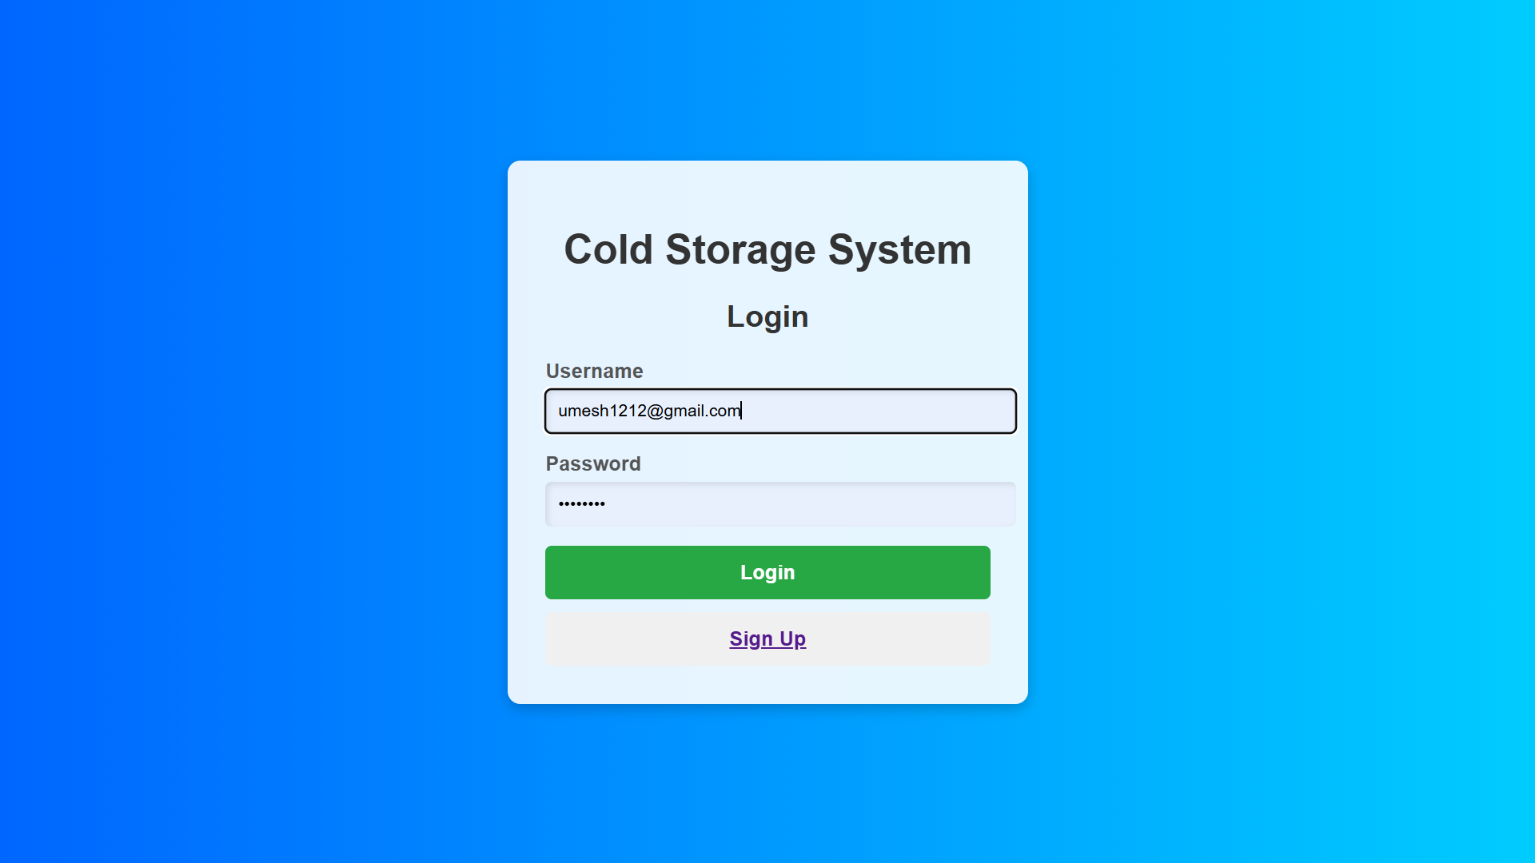**

**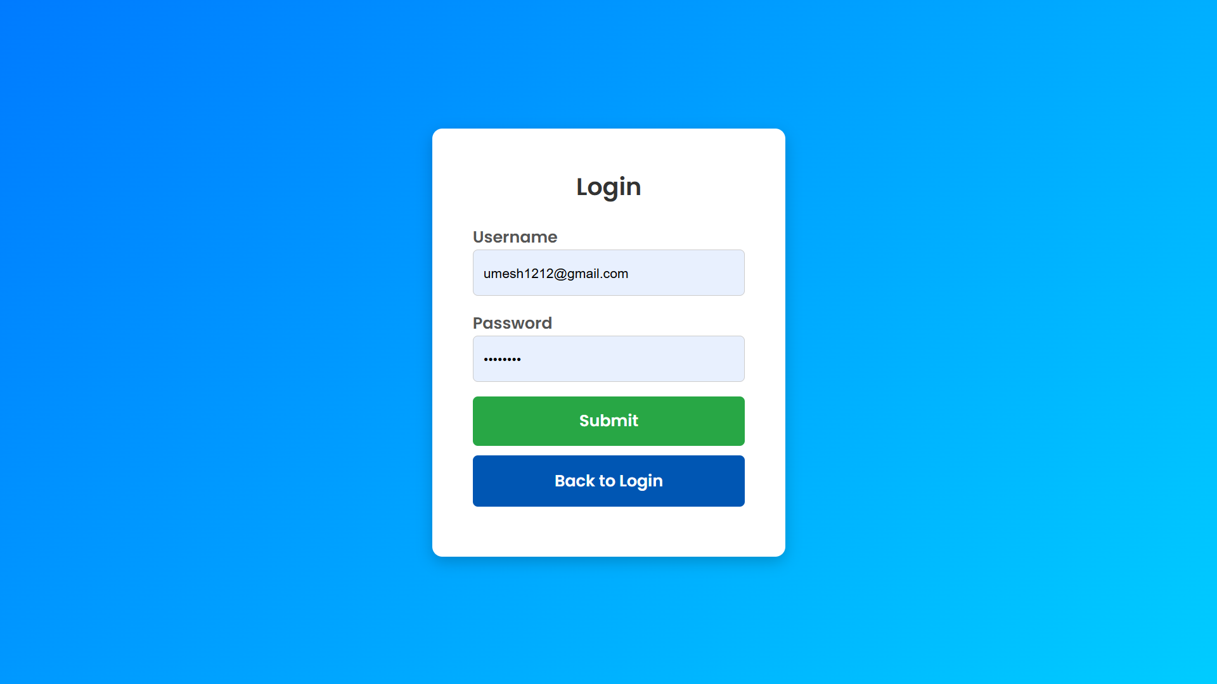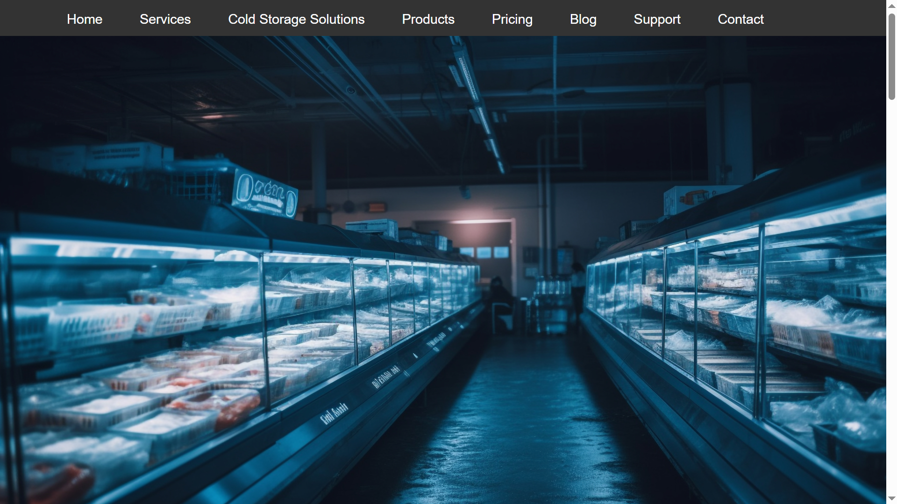**

**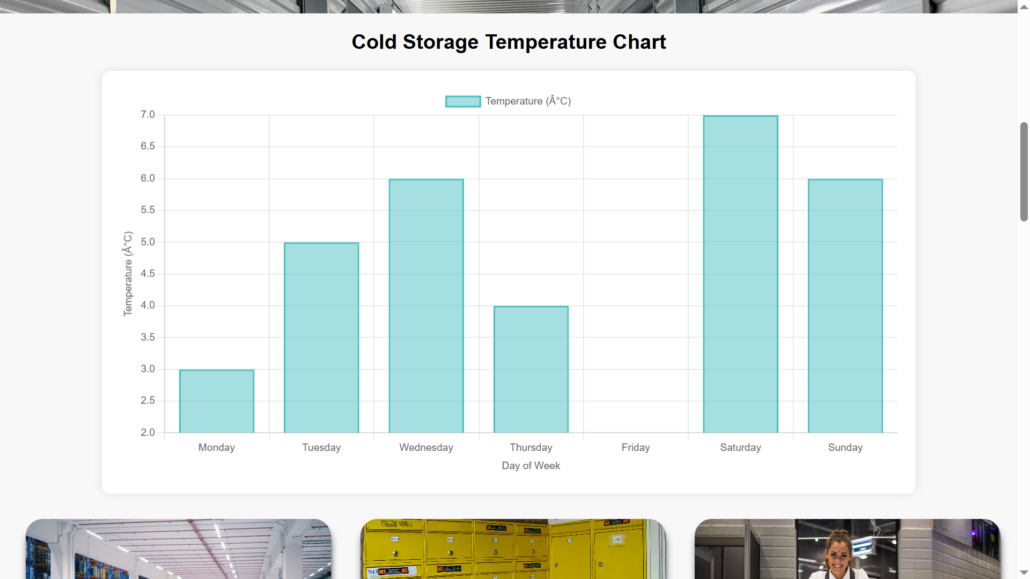**

**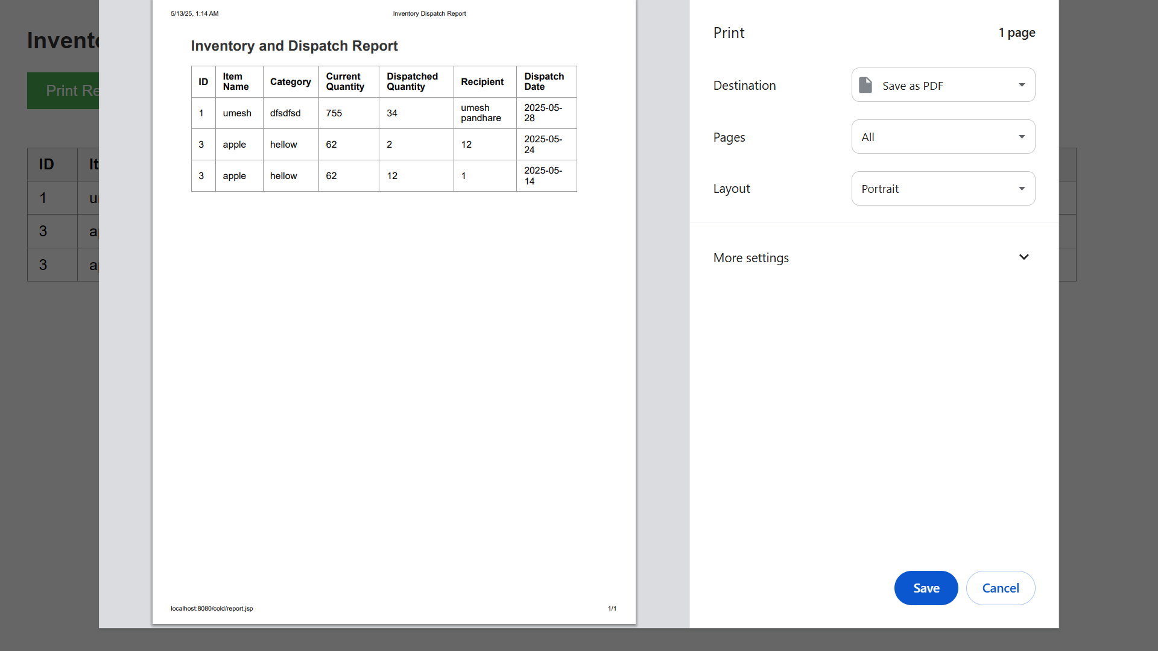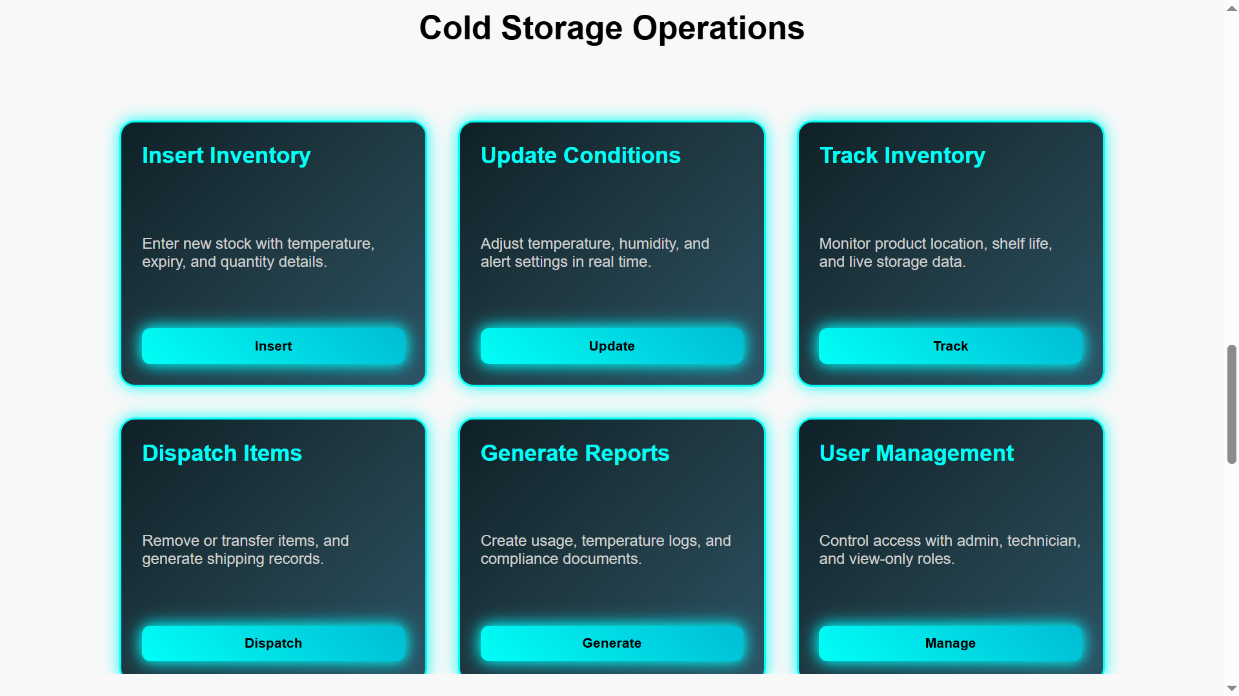**

**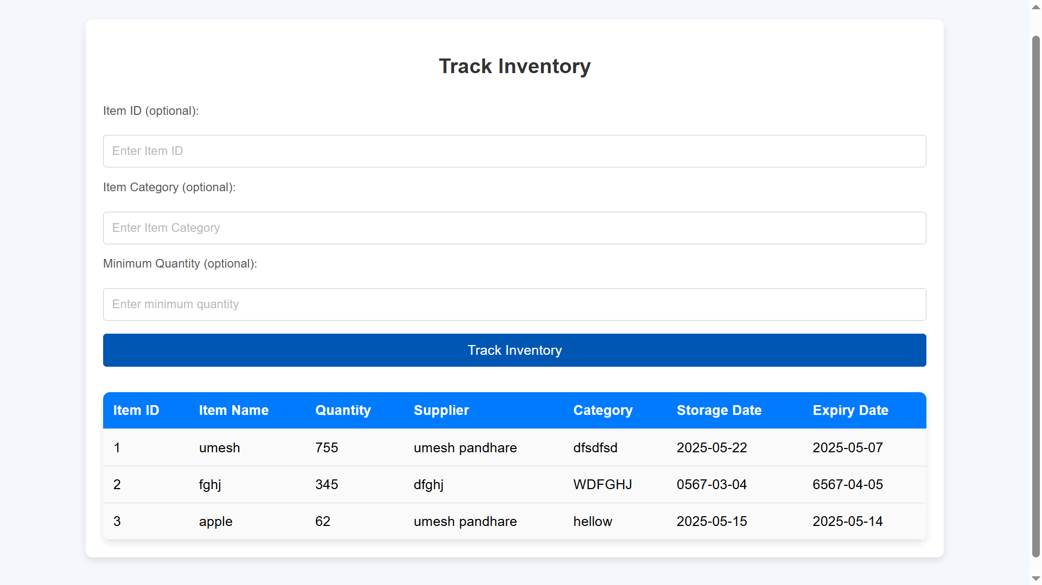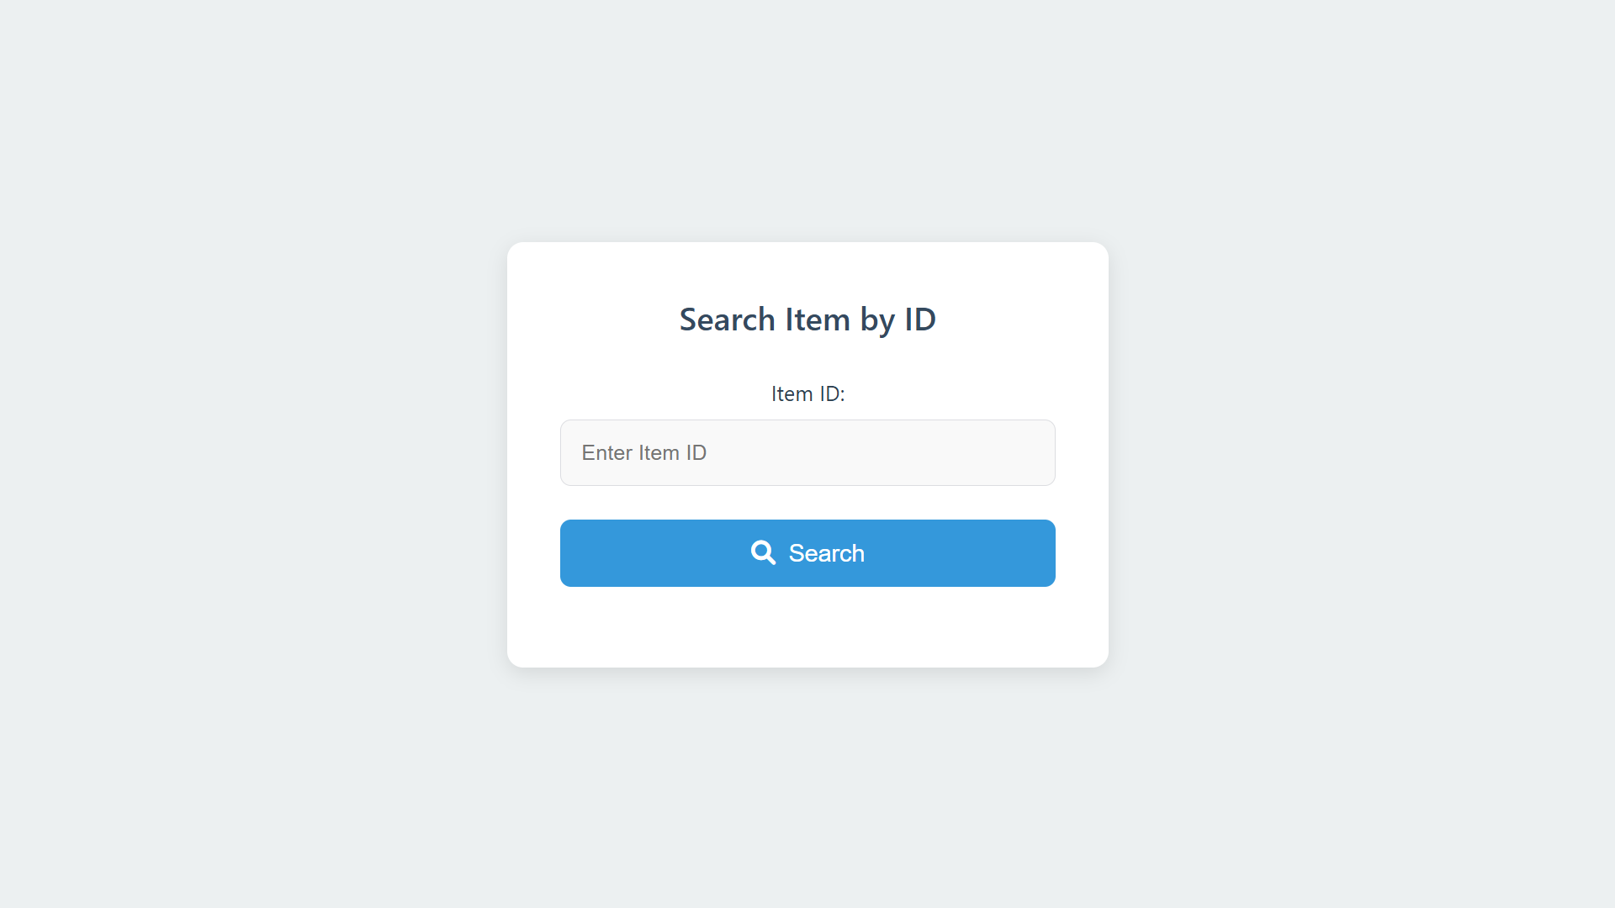**

**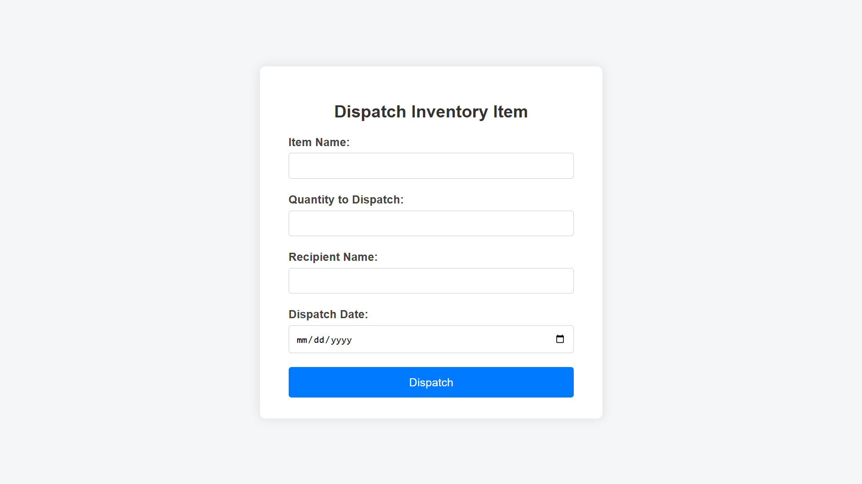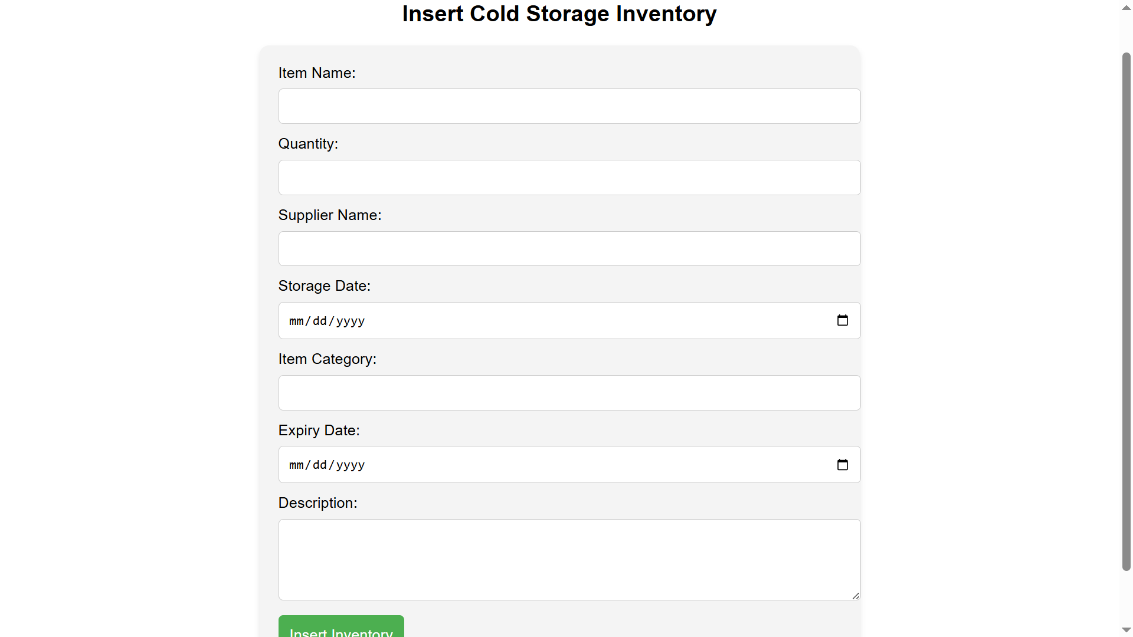**

**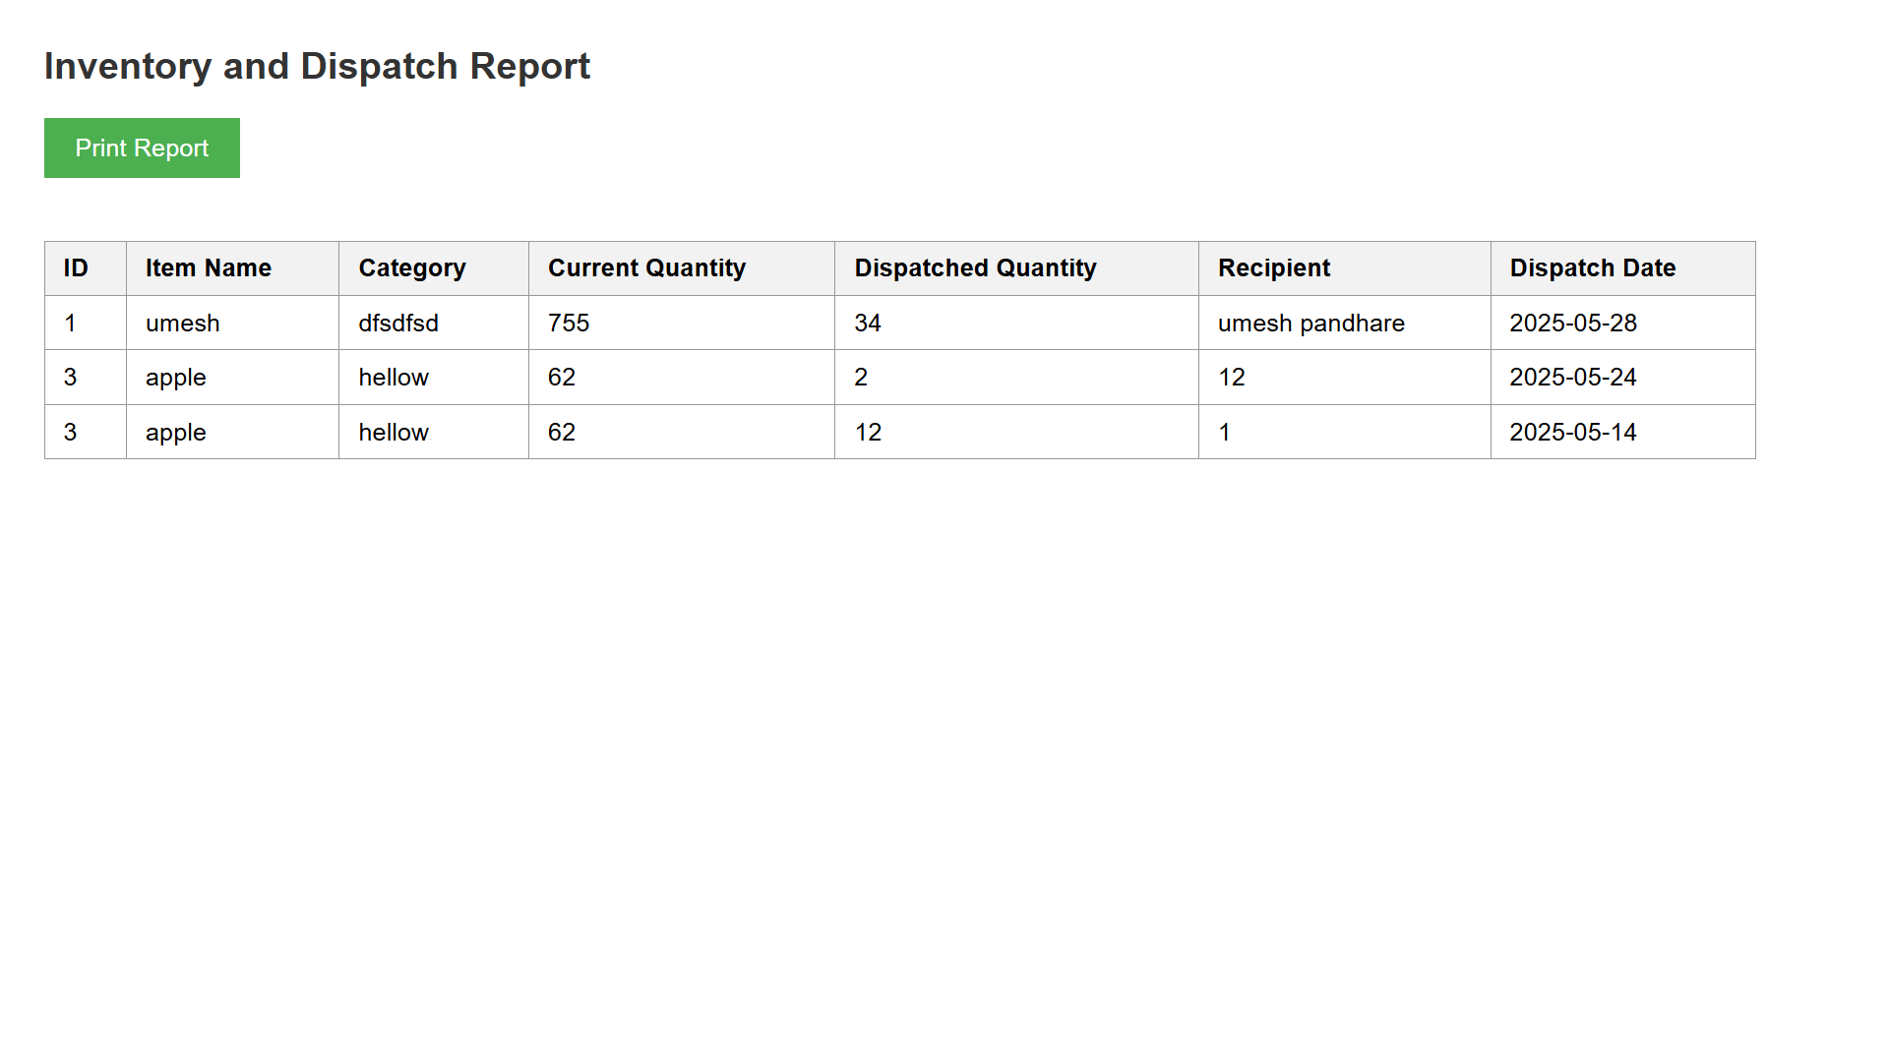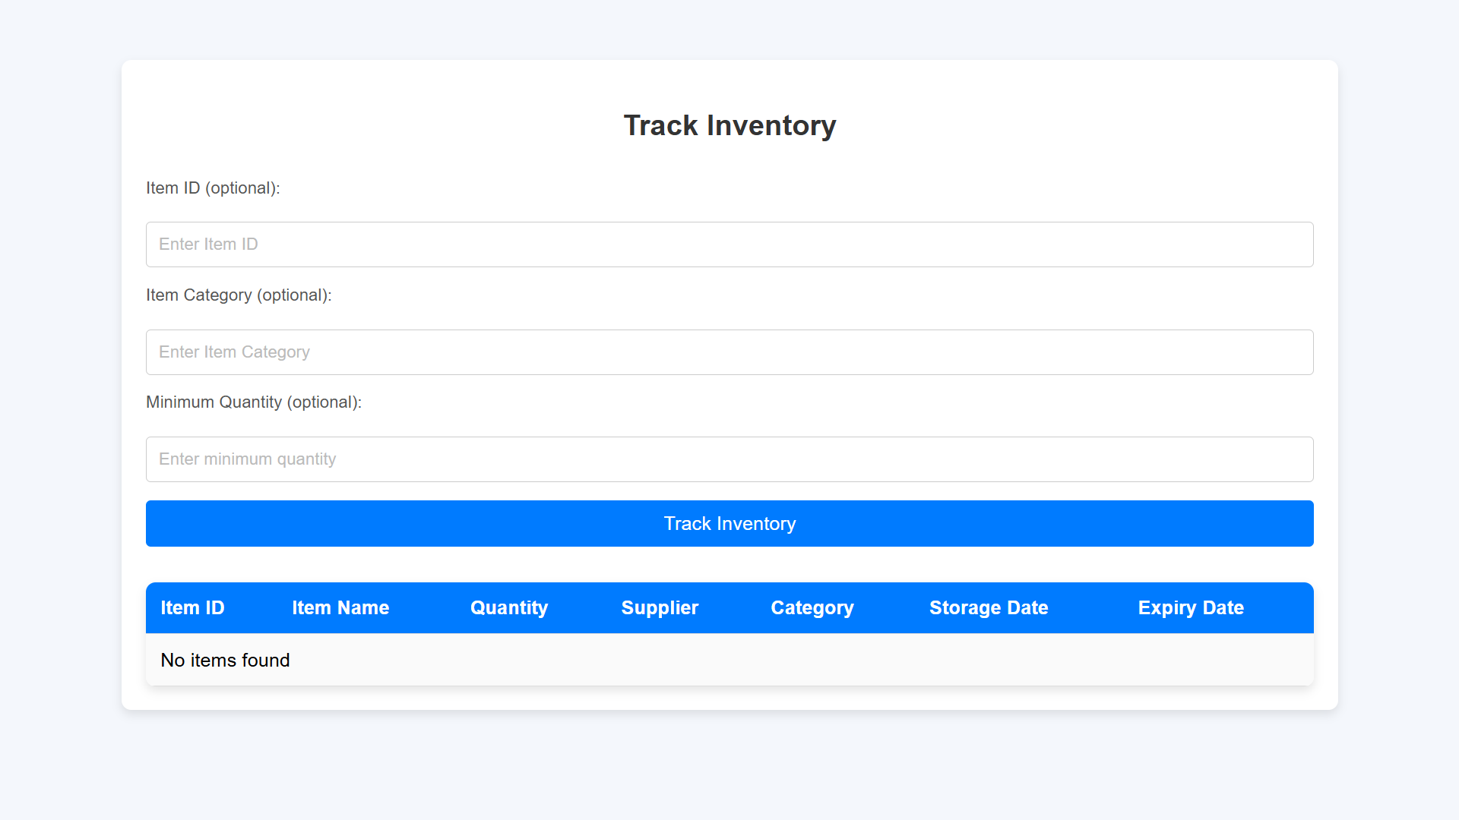**

**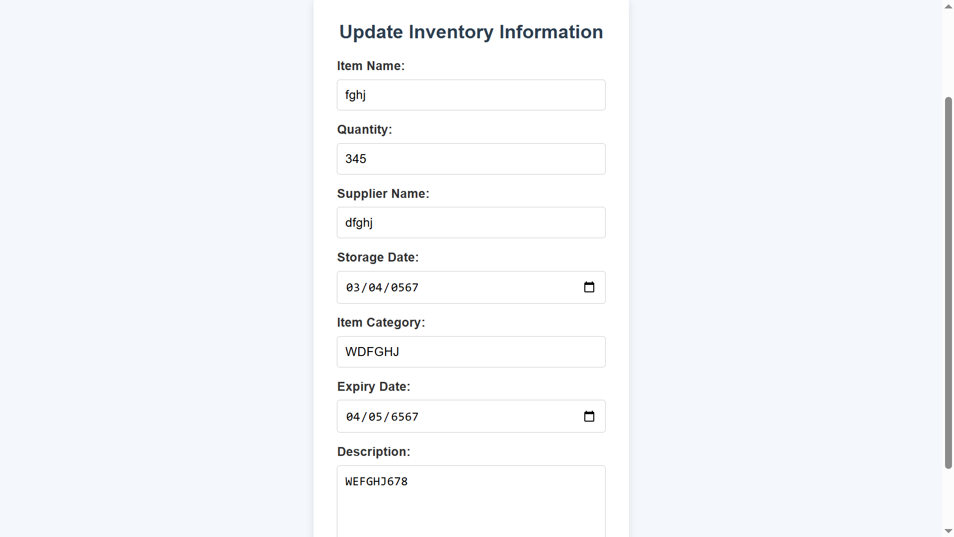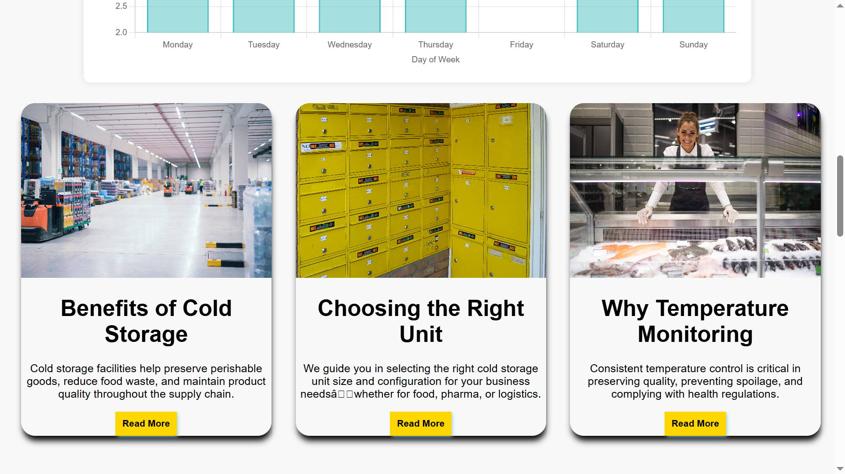**

**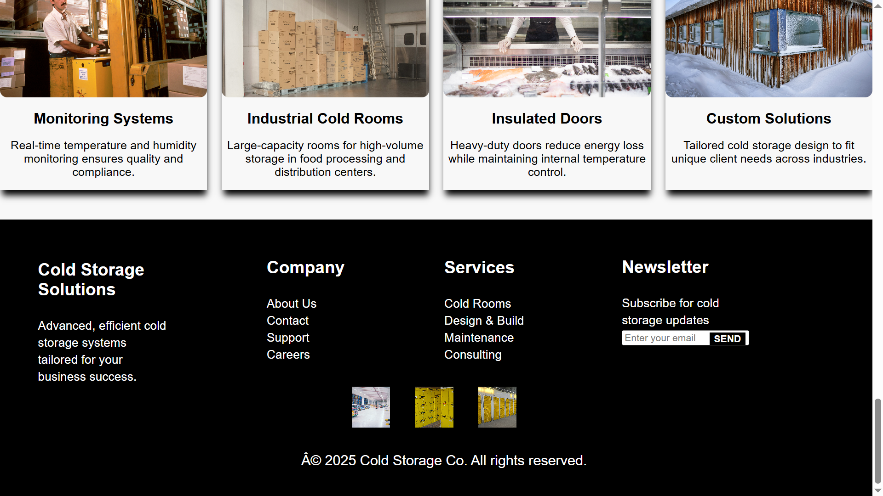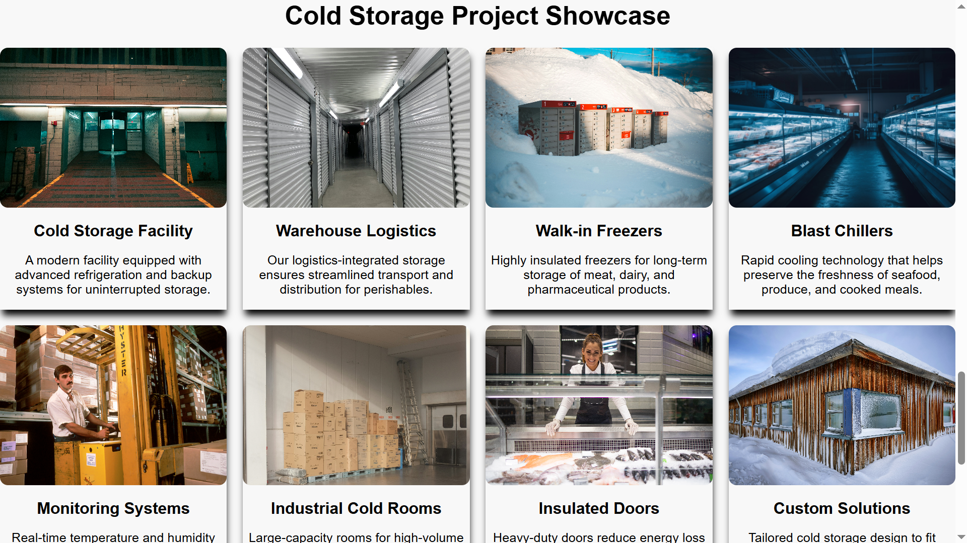**

**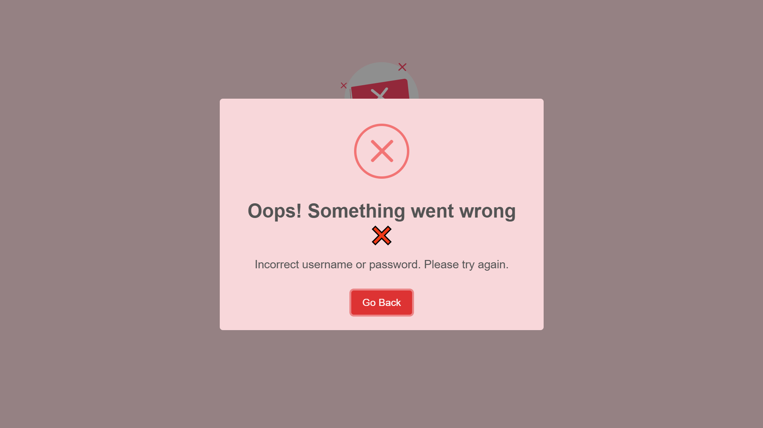**

Got it! If you have provided the screenshots of your UI design, I can offer you a concise explanation for each page based on those screenshots. Here’s a detailed breakdown of the possible UI functionality, even without the actual images:

### ****1. Login Page****

**Explanation**:

**Login Form**: The login page typically includes fields for entering the **username** and **password**. Once entered, the user can click the **Login button** to submit their credentials.

**Forgot Password**: There should be a link to help users who may have forgotten their password. It would redirect them to a password recovery page.

**Sign-Up Link**: For new users who need to create an account. This link redirects to the sign-up page for creating a new user account.

### ****2. Sign-Up Page****

**Explanation**:

**Create New Account**: The page should allow users to enter their details such as **username**, **password**, **confirm password**, and **role** (Admin or Staff).

**Password Confirmation**: A field for confirming the password ensures that users enter it correctly.

### ****3. Alert Page****

**Explanation**:

**Active Alerts**: The alert page shows **real-time notifications** related to inventory or environmental issues, such as temperature fluctuations or low stock levels.

**Clear Alerts**: Alerts can be dismissed by the user after acknowledging them, ensuring the system is actively monitored.

**History**: A section that might show past alerts, such as whether they were addressed or if the system restored normal conditions.

### ****4. Enter New Stock Page****

**Explanation**:

**Stock Information**: This page allows users to enter new inventory details like **item name**, **quantity**, **supplier**, **expiry date**, and **temperature settings**.

**Save Stock**: After entering all required information, the user can click the **Save** button to store the new item in the system.

**Temperature Settings**: Specifying the appropriate storage temperature for items ensures they are stored correctly in cold storage.

### ****5. Update Conditions Page****

**Explanation**:

**Temperature and Humidity Controls**: This page allows users to adjust the **environmental settings** of the cold storage, like **temperature** and **humidity**.

**Alert Settings**: Users can define thresholds for temperature or humidity, triggering an alert if those values go beyond the set limits.

**Real-Time Monitoring**: This ensures that conditions are always ideal for the products in storage and any deviations are flagged instantly.

### ****6. Track Inventory Page****

**Explanation**:

**Search and View Inventory**: A search bar allows users to find specific items. An inventory table shows all items in storage with information like **item name**, **quantity**, **location**, and **expiry date**.

**Stock Updates**: Users can click on an item to view more detailed information or update its status, such as quantity or location.

### ****7. Dispatch Items Page****

**Explanation**:

**Item Dispatch**: Users can **select an item** from inventory and specify the **dispatch quantity**, **recipient name**, and **dispatch date**.

**Create Dispatch Record**: After submitting, the system will create a **shipping record** or log that can be used for tracking the item’s movement.

**Stock Update**: The system will automatically update the **quantity** in the inventory when items are dispatched.

### ****8. Generate Reports Page****

**Explanation**:

**Report Generation**: This page allows users to generate **reports** related to usage, **temperature logs**, or **compliance**.

**Date Range**: Users can set a **start** and **end date** for the report period.

**Download**: Once the report is generated, users can download it as a PDF or Excel file for further review and compliance purposes.

### ****General Overview****

These pages form the backbone of the **Cold Storage Management System**, where users can:

**Authenticate** through Login and Sign-Up pages.

**Monitor** environmental conditions and inventory levels in real time.

**Manage** stock by adding new items and adjusting conditions.

**Track** and **dispatch** items as they move in and out of cold storage.

**Generate Reports** for audit purposes and compliance.

## ****System Implementation****

### ****4.1 Platform Details****

### ****Platform Overview:****

The Cold Storage System is implemented using a combination of technologies that ensure efficient inventory management, user management, and dispatch tracking. The system uses the following platforms and technologies:

#### ****1. Back-End Technology:****

**Java (Servlets and JSP)**:

**Java Servlets** are used for handling HTTP requests and responses, managing the server-side logic.

**JavaServer Pages (JSP)** is used for developing dynamic web pages by embedding Java code directly into HTML. JSP allows for seamless integration of the server-side logic with the front end.

#### ****2. Front-End Technology:****

**HTML/CSS**:

Used for creating the structure and styling of the user interface.

**JavaScript (JS)**:

Used for client-side functionality and interactivity, such as form validations and updating UI elements dynamically without reloading the page.

#### ****3. Database:****

**MySQL Database**:

Used to store the data in structured tables (cold storage user, inventory, dispatch logs, etc.).

The database allows for efficient querying, updating, and maintaining consistency in the data.

#### ****4. Development Environment:****

**Eclipse IDE**:

Eclipse is used as the Integrated Development Environment (IDE) for writing Java code (Servlets and JSP). It also supports MySQL database integration through connectors, making it easy to manage and connect the application to the database.

#### ****5. Server:****

**Apache Tomcat**:

Apache Tomcat is used to run the Servlets and JSP-based web application. It serves as the web server for handling HTTP requests and serving web pages.

### ****4.2 Module Description****

The Cold Storage System is divided into several modules, each responsible for different functionalities of the system. Below is an overview of the key modules:

#### ****1. User Management Module:****

**Purpose**: Allows administrators and staff to register, log in, and manage user credentials.

**Features**:

**Sign Up**: New users can register by providing a username, password, and role (Admin or Staff).

**Login**: Registered users can log in to the system using their credentials.

**Role Management**: Administrators can manage user roles and access rights.

#### ****2. Inventory Management Module:****

**Purpose**: Allows users to manage the inventory of items stored in cold storage.

**Features**:

**Add New Inventory**: Users can add new inventory items, specifying their name, quantity, supplier, category, storage date, temperature, and expiry date.

**Update Inventory**: Users can update details of existing inventory items (e.g., quantity, temperature, expiry date).

**Track Inventory**: View and search for items in the cold storage inventory, along with their details.

#### ****3. Dispatch Tracking Module:****

**Purpose**: Allows users to manage the dispatch of items from the cold storage.

**Features**:

**Log Dispatch Events**: Users can log dispatch events, specifying the item, quantity, recipient, and dispatch date.

**Track Dispatch**: Allows for tracking dispatched items, including viewing tracking numbers, status, and shipping addresses.

#### ****4. Report Generation Module:****

**Purpose**: Allows users to generate various reports related to inventory, temperature logs, and dispatches.

**Features**:

**Inventory Report**: Generate reports on the current inventory status, including quantities, categories, and expiry dates.

**Temperature Log Report**: Generate reports for monitoring the temperature history and compliance.

**Dispatch Report**: Generate dispatch records, including shipment tracking and recipient information.

#### ****5. Real-Time Monitoring Module:****

**Purpose**: Provides real-time data about the cold storage environment (temperature, humidity) and alerts for out-of-range conditions.

**Features**:

**Monitor Conditions**: View the current temperature and humidity levels inside the cold storage.

**Adjust Settings**: Modify temperature and humidity settings in real time to ensure compliance with storage requirements.

**Alert System**: Get alerts if the temperature or humidity goes out of the defined range.

### ****4.3 Input and Output Design****

#### ****Input Design:****

The input design for the Cold Storage System ensures that the data entered by users is accurate, valid, and consistent. Below are the key inputs:

#### ****1. User Input:****

**Sign Up Page**:

**Username**: A unique identifier for the user.

**Password**: A secure password for user authentication.

**Role**: Defines the user’s access level (Admin, Staff).

**Login Page**:

**Username**: The username provided by the user.

**Password**: The password entered by the user for authentication.

#### ****2. Inventory Input:****

**Add New Inventory Page**:

**Item Name**: The name of the item being added to inventory (e.g., Frozen Peas).

**Quantity**: The number of items available in storage.

**Supplier Name**: Name of the supplier providing the item.

**Storage Date**: The date when the item was stored in the cold storage.

**Item Category**: The type of item (e.g., Vegetables, Meat).

**Expiry Date**: The date when the item is set to expire.

**Temperature**: The storage temperature required for the item.

**Update Inventory Page**:

**Item ID**: Unique identifier of the item to be updated.

**Updated Details**: The updated details such as quantity, expiry date, and temperature.

#### ****3. Dispatch Input:****

**Dispatch Log Page**:

**Item ID**: The item being dispatched.

**Dispatch Quantity**: The number of items being dispatched.

**Recipient Name**: The recipient of the dispatched items.

**Dispatch Date**: The date the items were dispatched.

#### ****4. Report Generation Input:****

**Report Generation Page**:

**Item ID (Optional)**: Specific item for generating reports.

**Item Category (Optional)**: Filter reports based on item category.

**Minimum Quantity (Optional)**: Filter reports to show only items with stock less than the specified quantity.

#### ****Output Design:****

The system produces the following outputs for user interaction and reporting:

#### ****1. User Output:****

**Login Success/Failure**: Displays a success message when login is successful or an error message if the login fails.

**User Role and Permissions**: Outputs the user's role (Admin, Staff) to determine which features are accessible.

#### ****2. Inventory Output:****

**Item Details**: Display detailed information about inventory items, including name, quantity, supplier, temperature, expiry date, and item category.

**Inventory Status**: Show a summary of current inventory, highlighting any low-stock items or expired goods.

#### ****3. Dispatch Output:****

**Dispatch Confirmation**: Shows confirmation when an item has been successfully dispatched, including the item name, quantity, recipient, and dispatch date.

**Dispatch Records**: Displays a detailed log of all dispatches, including status updates such as "Shipped," "In Transit," or "Delivered."

#### ****4. Report Output:****

**Inventory Report**: Generates and displays a printable report with the list of inventory items, quantities, expiry dates, and categories.

**Temperature Log Report**: Outputs a report showing temperature trends over time and compliance with the required storage conditions.

**Dispatch Report**: Displays a detailed dispatch report, including tracking numbers, recipient information, and shipping details.

#### ****5. Real-Time Monitoring Output:****

**Temperature and Humidity Status**: Displays real-time readings for the temperature and humidity inside the cold storage.

**Alert Notifications**: Sends real-time alerts to users if the temperature or humidity goes out of the defined acceptable range.

Here is the **Chapter 6: Conclusion & Future Scope** section of your Cold Storage System documentation, formatted and ready for inclusion in your report or Word document:

## ****Conclusion & Future Scope****

### ****6.1 Achievements****

The Cold Storage Management System successfully meets the primary goals defined during system planning and analysis. The achievements of the project include:

**Efficient Inventory Management**: Users can insert, update, and monitor inventory items including details like quantity, expiry, and temperature.

**User Authentication System**: Secure login and registration modules ensure that only authorized users can access system functions.

**Real-time Monitoring**: The system tracks and displays live environmental data (temperature and humidity), essential for cold storage reliability.

**Dispatch and Logistics Tracking**: The system maintains accurate records of dispatch events, including recipient, quantity, and tracking details.

**Automated Reporting**: Customizable reports for inventory levels, temperature logs, and dispatch history enhance transparency and accountability.

**Role-Based Access**: Separation of Admin and Staff privileges ensures proper access control and system security.

**User Interface**: A dynamic, user-friendly UI using JSP ensures that users can easily interact with all features, including stock input and alert systems.

### ****6.2 Limitations****

While the system is fully functional and meets the core objectives, a few limitations exist:

**No Mobile App Interface**: The current system is web-based and does not offer mobile platform support, which may limit access for on-the-go users.

**Basic Alert System**: Alerts are displayed on the dashboard but lack push notification or email integration for critical condition warnings.

**Manual Data Entry**: Sensor data for temperature and humidity must currently be entered manually unless integrated with IoT devices.

**No Advanced Analytics**: Reports are basic and do not include predictive analytics or AI-based insights (e.g., shelf-life prediction).

**Limited User Roles**: Only two user roles (Admin and Staff) are supported. Larger operations may require finer-grained role management.

### ****6.3 Future Enhancements****

To address the current limitations and improve the system’s performance, the following future enhancements are proposed:

**Mobile Application**: Develop Android/iOS apps for real-time inventory management and condition alerts on mobile devices.

**IoT Integration**: Integrate with sensors to automatically record and monitor real-time environmental conditions.

**Advanced Notification System**: Implement email and SMS alerts for urgent events (e.g., temperature out of range, item expiration).

**Barcode/QR Code Integration**: Use scanning technology for faster data entry, tracking, and inventory checks.

**Multi-Warehouse Support**: Expand the system to support operations across multiple cold storage units or warehouses.

**Role Hierarchy and Permissions**: Introduce role-based access control with customizable permissions for large teams.

**Predictive Analytics**: Incorporate AI/ML to analyze trends and make predictions on inventory usage and spoilage.

### ****Conclusion****

The Cold Storage Management System offers a strong foundation for digitally managing perishable inventory. With features like real-time tracking, secure user management, and dispatch monitoring, the system significantly improves operational efficiency. While some enhancements are needed for scalability and automation, the current implementation serves as a robust prototype for real-world deployment.

.

## ****References****

The following resources, tools, and technologies were referred to and utilized during the development of the Cold Storage Management System:

### ****7.1 Books & Academic Resources****

**"Head First Servlets and JSP"** – Kathy Sierra, Bert Bates  
(For understanding the core concepts of Java Servlets and JSP development.)

**"Database System Concepts"** – Abraham Silberschatz, Henry F. Korth  
(Used for guidance on relational database modeling and normalization.)

### ****7.2 Online Resources****

[Oracle Java Documentation](https://docs.oracle.com/en/java/" \t "_new)  
(For detailed reference on Java classes, Servlets, and JSP APIs.)

[MySQL Official Documentation](https://dev.mysql.com/doc/" \t "_new)  
(For database creation, SQL syntax, and foreign key constraints.)

[W3Schools (HTML, CSS, JS)](https://www.w3schools.com" \t "_new)  
(For front-end design concepts and examples.)

[Stack Overflow](https://stackoverflow.com/" \t "_new)  
(For resolving coding errors, best practices, and implementation issues.)

[GeeksforGeeks – Servlet & JSP Tutorials](https://www.geeksforgeeks.org/" \t "_new)  
(For Java Servlet and JSP coding examples and troubleshooting.)

### ****7.3 Tools & Technologies Used****

**Eclipse IDE** – Java development environment for coding and project management.

**Apache Tomcat Server** – Web server for deploying and testing JSP/Servlet applications.

**MySQL Workbench** – GUI tool for managing the MySQL database.

**XAMPP (Optional)** – Local server environment (if used during testing).

**JSP, HTML5, CSS3, JavaScript** – Technologies for creating user interfaces.

**Java EE (Servlet API)** – Framework used for back-end logic and processing.

**Microsoft Word / Google Docs** – Used for preparing the documentation.

### ****7.4 Personal Contributions & Guides****

Custom database schema and UI design based on cold storage real-world requirements.

Discussions and guidance from mentors, faculty members, and online community forums.

* Appendix: Source Code

INDEX.JSP

<%@ page language=*"java"* contentType=*"text/html; charset=UTF-8"* pageEncoding=*"UTF-8"* %>

<!DOCTYPE html>

<html lang=*"en"*>

<head>

<meta charset=*"UTF-8"*>

<meta name=*"viewport"* content=*"width=device-width, initial-scale=1.0"*>

<title>Cold Storage Login</title>

<style>

**body** {

font-family: *'Poppins', sans-serif*;

background: *linear-gradient(to right, #0066ff, #00ccff)*;

display: *flex*;

justify-content: *center*;

align-items: *center*;

height: *100vh*;

margin: *0*;

}

*.login-container* {

background: *rgba(255, 255, 255, 0.9)*;

padding: *30px*;

border-radius: *10px*;

box-shadow: *0 4px 10px rgba(0, 0, 0, 0.2)*;

width: *350px*;

text-align: *center*;

}

**h1** {

margin-bottom: *10px*;

color: *#333*;

}

**h2** {

margin-bottom: *20px*;

color: *#333*;

}

*.input-group* {

margin-bottom: *15px*;

text-align: *left*;

}

**label** {

display: *block*;

margin-bottom: *5px*;

font-weight: *bold*;

color: *#555*;

}

**input**[type="text"]**,**

**input**[type="password"] {

width: *100%*;

padding: *10px*;

border: *none*;

border-radius: *5px*;

box-shadow: *inset 2px 2px 5px rgba(0, 0, 0, 0.1)*;

}

**button** {

width: *100%*;

padding: *12px*;

border: *none*;

border-radius: *5px*;

cursor: *pointer*;

font-size: *16px*;

font-weight: *bold*;

transition: *0.3s*;

}

*.login-btn* {

background-color: *#28a745*;

color: *white*;

margin-bottom: *10px*;

}

*.login-btn:hover* {

background-color: *#218838*;

}

*.signup-btn* {

background-color: *#007bff*;

color: *white*;

}

*.signup-btn:hover* {

background-color: *#0056b3*;

}

*.error* {

color: *red*;

margin-top: *10px*;

}

</style>

</head>

<body>

<div class=*"login-container"*>

<h1>Cold Storage System</h1>

<h2>Login</h2>

<form id=*"loginForm"* method=*"post"* action=*"a"*>

<div class=*"input-group"*>

<label for=*"username"*>Username</label>

<input type=*"text"* id=*"username"* name=*"t1"* required>

</div>

<div class=*"input-group"*>

<label for=*"password"*>Password</label>

<input type=*"password"* id=*"password"* name=*"t2"* required>

</div>

<button type=*"submit"* class=*"login-btn"*>Login</button>

</form>

<button><a href=*"k.jsp"*>Sign Up</a></button>

</div>

</body>

</html>

**LOGIN.JAVA**

package com.nt;

import java.io.IOException;

import java.sql.Connection;

import java.sql.DriverManager;

import java.sql.PreparedStatement;

import java.sql.ResultSet;

import java.sql.SQLException;

import jakarta.servlet.RequestDispatcher;

import jakarta.servlet.ServletException;

import jakarta.servlet.http.HttpServlet;

import jakarta.servlet.http.HttpServletRequest;

import jakarta.servlet.http.HttpServletResponse;

public class login extends HttpServlet {

@Override

protected void service(HttpServletRequest req, HttpServletResponse res) throws ServletException, IOException {

String name = req.getParameter("t1");

String password = req.getParameter("t2");

System.out.println("User input name: " + name);

System.out.println("User input password: " + password);

try {

Class.forName("com.mysql.cj.jdbc.Driver");

try (Connection con = DriverManager.getConnection("jdbc:mysql://localhost:3306/users", "root", "root123")) {

PreparedStatement ps = con.prepareStatement("SELECT name, password FROM user");

ResultSet rs = ps.executeQuery();

boolean isValidUser = false;

while (rs.next()) {

String dbName = rs.getString("name");

String dbPassword = rs.getString("password");

if (name.equals(dbName) && password.equals(dbPassword)) {

isValidUser = true;

break;

}

}

if (isValidUser) {

RequestDispatcher rd = req.getRequestDispatcher("main.jsp");

rd.forward(req, res);

} else {

// res.setContentType("text/html");

// res.getWriter().println("<script>");

// res.getWriter().println("alert('Incorrect username or password. Please try again.');");

// res.getWriter().println("window.location.href='index.jsp';");

// res.getWriter().println("</script>");

String message = "Incorrect username or password. Please try again.";

req.setAttribute("uk",message);

RequestDispatcher rd=req.getRequestDispatcher("ktm.jsp");

rd.forward(req, res);

}

}

} catch (ClassNotFoundException | SQLException e) {

e.printStackTrace();

res.setContentType("text/html");

res.getWriter().println("<p>Error fetching user data.</p>");

}

}

}